Data Management Plan

IDV Project: “Hear & Now”

Group 6

Contents

Data Management Plan 2

2.1 Organizational Context 2

2.2 Description Project 2

2.3 Data Management Roles 2

2.4 Project Data 2

2.5 Short Term Storage Solutions 3

2.6 Data Management and Naming Structure (flow chart) 3

2.7 Sharing and Ownership 4

2.9 Long Term Storage 4

# Data Management Plan

## 2.1 Organizational Context

|  |  |
| --- | --- |
| **Name** | ACT Project Group 6 |
| **Date** | 19.05.2023 |
| **Chair group** | Geo-Information and Remote Sensing (GRS) |
| **GRS supervisor** | Dr.Ir. Lammert Kooistra |
| **Start date project** | 21.05.2023 |
| **File name DMP** | DMP_draft_group06 |

## 2.2 Description Project

|  |  |
| --- | --- |
| **Title** | Hear & Now |
| **Abstract** | Our goal is to develop an interactive web application where the users can get an immersive experience in the Achterhoek region. Notably, we want to provide the users with information about the bird diversity in the region, its relationship with the ecosystems found there and the effects of agricultural pressure on the habitat loss of the birds that are present in the area.  The web application will give this immersive experience by scaling down from satellite imagery to terrestrial laser scanned data with which the user, like a bird, will get the feeling of flying to their home habitat. The habitats that the user will be able to fly to are forests, crops, wetlands and urban areas. For each of these four areas an analysis of the vegetation present will be done by mixing vegetation indices (retrieved from UAV (Unmanned Aerial Vehicles) imagery) and forest structure variables (Retrieved from MLS (Mobile Laser Scanning)). Finally, the recording of birds singing will be available to listen for each of the habitats with one list of the bird species that were found during our visit to the area and another list of the birds that have been observed recently near this area (Citizen science data retrieval from eBird). |

## 2.3 Data Management Roles

|  |  |
| --- | --- |
| **Who is collecting the data** | Each member of the group will participate to the data collection, splitting in 3 groups (1 group for AudioMoth, 1 for MLS and all the members for the drone flights) |
| **Who is analysing the data** | Each member of the group will analyse data from a specific data source, dividing the workload. |
| **Other** | Ebird, BirdNet, Sentinel 2, Landsat, MODIS |
| **Role supervisor** | Supervision, no data collection/analysis/storage |

## 2.4 Project Data

|  |  |  |  |
| --- | --- | --- | --- |
| **Data Stage** | **Data Type** | **Software choice** | **Data size** |
| **Source Data** | Audio rec (WAV) | Python to extract the data;  BirdNet (to recognise the bird species) | 10 GB |
| Point cloud | Python (FSCT package)  CloudCompare | 10 GB |
| Satellite data | Python, GEE | Cloud |
| Cit. Science | Python (Ebird App) | ~ 50MB |
| **Result Data** | Bird species AudioMoth | Python (BirdNet) | Not stored |
| Forest structure/  3D point cloud model (UAV) | CloudCompare and FSCT (Python) | 10 GB |
| Vegetation indices (satellite imagery) | Google Earth Engine | 10 MB |
| **Models/ Code** | EBird API data retrieval (python script) | Python | Stored online |
| Dashboard creation with list of recent bird observations (python script) | Python | Stored online |
| Bird species detection from audio and BirdNet (python script) | Python | Stored online |
| Forest structure variables estimation (python script) | Python | Stored online |
| Vegetation indices calculation from Satellite imagery (python script) | Python | Stored online |

## 2.5 Short Term Storage Solutions

|  |  |  |
| --- | --- | --- |
| **Data Stage** | **Storage Location** | **Backup Procedures** |
| **Source Data** | Hard drive | GitHub, OneDrive and Google Drive |
| **Results Data** | Hard drive | Arcgis Online, Github |
| **Models/ Code** | Hard drive | Github |

## 2.6 Data Management and Naming Structure (flow chart)

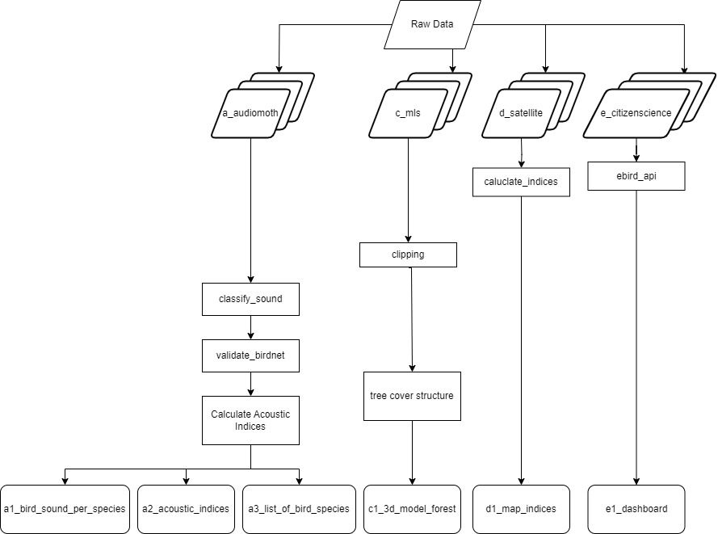

## 2.7 Sharing and Ownership

|  |  |
| --- | --- |
| **Sharing and ownership** | **With whom/ what/ how** |
| **Data Sharing** | The data we will use will be stored in a share OneDrive folder |
| **Data Ownership** | Users can access and visualise the final product and the data we used- but not edit the data (except for potential contributors) |
| **Privacy** | There are not privacy or security issues |

## 2.9 Long Term Storage

|  |  |
| --- | --- |
| **Yes or No** | **Argumentation** |
| Yes | Our final project will be an ArcGIS StoryMaps Collection and a web app created with PythonAnywhere, so will be stored in the ArcGIS Online portal, and the data that we are using will be stored in a shared GitHub, Google Drive, OneDrive folder. |